**Task 11**

**Computer Networks (Lab)**



**Submitted to Mr. Rasikh Ali  
Submitted by M.Naqeeb**

**Roll #: SU92-BSSEM-F22-100  
Section: SE-5B**

**Submitted on Dec 09, 2024**

**DEPARTMENT OF SOFTWARE ENGINEERING  
SUPERIOR UNIVERSITY, LAHORE**

Contents

DHCP, VLAN & DNS 3

Dynamic Host Configuration Protocol (DHCP) 3

Example 3

Virtual Local Address Network (VLAN) 3

Example 3

Domain Name System (DNS) 3

Example 3

# DHCP, VLAN & DNS

## Dynamic Host Configuration Protocol (DHCP)

DHCP is a network management protocol used to dynamically assign IP addresses to devices on a network. This eliminates the need for network administrators to manually assign static IP addresses to each device.

When a device connects to a network, it sends a DHCP Discover request for an IP address. The DHCP server responds by assigning an available IP address from a pool and sends other network information.

### Example

Imagine you're connecting your laptop to a Wi-Fi network at a coffee shop. To do that:

1. Your laptop sends a DHCP Discover message.
2. The DHCP server responds with an IP address, subnet mask, and other network information.
3. Your laptop can now communicate with other devices on the network and access the internet.

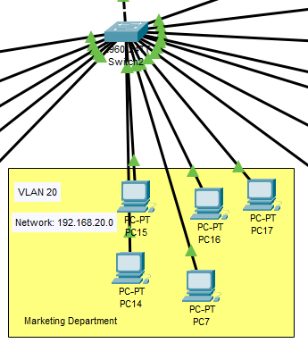

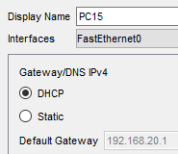

## Virtual Local Address Network (VLAN)

A VLAN is a logical grouping of devices on a LAN, which can be configured to behave as though they are on the same physical network, even if they are located on different parts of the physical infrastructure.

VLANs allow network administrators to segment a network into smaller, isolated sections for reasons such as improving performance, security, or management. Devices on different VLANs cannot communicate with each other unless routing is configured between them, often through a Layer 3 device like a router or Layer 3 switch.

### Example

In an office, there are three departments: HR, Finance, and IT. Without VLANs, all devices in these departments would be on the same network, meaning anyone from HR could communicate directly with Finance or IT, potentially compromising security or causing network congestion. But, with VLANs, the network administrator creates three VLANs

* VLAN 10: HR
* VLAN 20: Finance
* VLAN 30: IT

Now, each department’s devices can communicate only within their own VLAN unless routing is configured. This provides better security and performance because the traffic between departments is isolated.

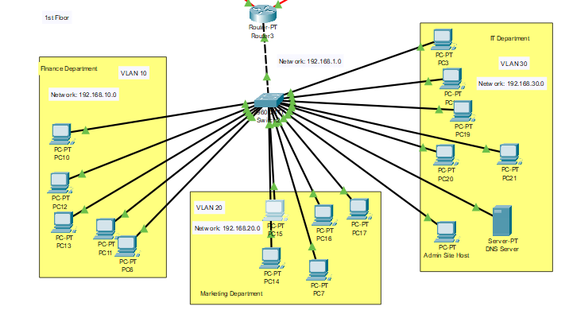

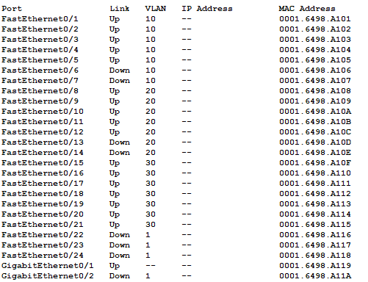

## Domain Name System (DNS)

DNS is the system that translates human-readable domain names like www.example.com into machine-readable IP addresses like 192.168.1.1.

When you type a URL into a web browser, DNS is used to find the corresponding IP address of the website so your device can connect to it. The process involves DNS servers that store records of domain names and their corresponding IP addresses.

### Example

You want to visit [www.example.com](http://www.example.com). To do that,

1. You type www.example.com into your browser.
2. The browser sends a request to a DNS server asking for the IP address of www.example.com.
3. The DNS server responds with the IP address (e.g., 93.184.216.34).
4. Your browser then uses this IP address to connect to the website and load the content.

